**Unit 09 CNN Model activity**

*Read the Wall (2019) article and record your thoughts on the ethical and social implications of this CNN technology.*

Wall (2019) explores the social and ethical issues that emerge from using facial recognition machine learning in law enforcement and security forces. The article recognizes that if the models used were 100% accurate the use case could save many lives in preventing terrorism or potential crime, in most cases though ML models are not completely accurate, and this could result in involving and harming innocent people as a result.

The use of live facial recognition and tracking can infringe on innocent people's privacy, have issues with accuracy as mentioned above and are hard to use at scale (Preez, 2024). Other downsides to such large-scale use are:

* It creates data vulnerabilities for people's personal and biometric information.
* The data collected and stored can be used for fraud and crime.
* A lack of transparency and accountability on its use (Gargaro, 2024).
* Biased datasets can create inaccuracies surrounding marginalised groups.

While there are ethical issues that need to be recognised with the use of widespread facial recognition technologies, this does not mean the technology should be discounted, the technology has multiple beneficial uses to society and institutions. To minimise the issues, deployment of these systems should be more controlled and transparent, oversight on the accuracy of the model, data management and security needs more thought, and the issue surrounding the use of the data and the public's permission to use their personnel data needs a more inclusive approach.

*Run this CNN model - Convolutional Neural Networks (CNN) - Object Recognition.ipynb - and review different sections of the algorithm. Change the input image for prediction by changing the value of this variable - plt.imshow(x_test[16] - from 16 to value of your choice (1-15) and see whether the model predicts correctly.*

The CNN in [***Convolutional Neural Networks (CNN) - Object Recognition.ipynb***](https://www.my-course.co.uk/pluginfile.php/1266060/mod_page/content/2/Unit09%20Ex1%20Convolutional%20Neural%20Networks%20%28CNN%29%20-%20Object%20Recognition.ipynb)consists of:

* Input Conv2D layer with 32 filters, kernel size (4, 4), input shape specified and the activation function of ReLU. It is then followed by a MaxPool2D layer which further reduces the output shape to extract features.
* Followed by another Conv2D and MaxPool2D layer block with the same parameters.
* A Flatten layer to reshape the output of the Convolutional layer ready to be input into the Dense layer (final layer). The dense layer only takes 1 dimensional input data.
* 1 Dense hidden layer with 256 neurons.
* Final Dense layer with 10 neurons to match the number of classes in the dataset to be classified. The activation function is softmax in this case to create a probability distribution for the categories.

The fitting of the model stopped early after 7 epochs, a validation accuracy of 65% and validation loss of 1.092.

When observing the validation and loss curves the model is overfitting.

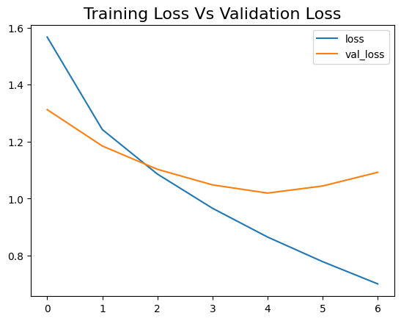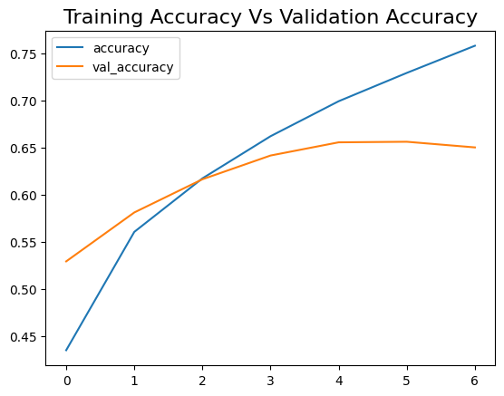

When predicting on random images, it got some correct predictions however notably predicted an “automobile” as a “bird”.

*Be prepared to review your thoughts and findings during next week’s seminar.*

***Learning Outcomes***

* *Articulate the legal, social, ethical and professional issues faced by machine learning professionals.*
* *Understand the applicability and challenges associated with different datasets for the use of machine learning algorithms.*

**References**

Wall, M. (2019). Biased and wrong? Facial recognition tech in the dock. BBC News. 8 Jul. Available at: <https://www.bbc.co.uk/news/business-48842750> [Accessed 16 January 2025].

Preez, D.(2024). Further concerns raised about use of facial recognition technology in UK - ‘effectively privatized policing’. diginomica. Available at: https://diginomica.com/further-concerns-raised-about-use-facial-recognition-technology-uk-effectively-privatized-policing [Accessed 26 Jan. 2025].

Gargaro, D. (2024). The Pros and Cons of Facial Recognition Technology. ITPro. Available at: <https://www.itpro.com/security/privacy/356882/the-pros-and-cons-of-facial-recognition-technology> [Accessed on 26 January 2025].